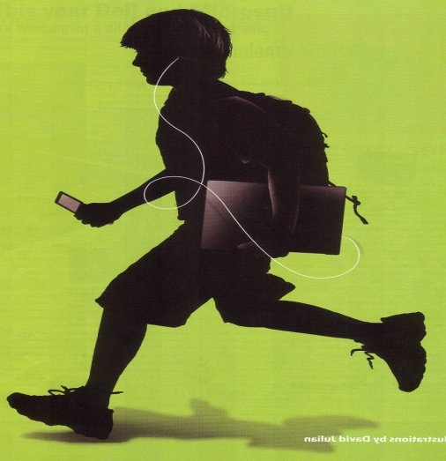
Are You Connected?

Digital natives use shorthand when communicating through Instant Messaging (IM).
How many 21st century acronyms do you know?
Take your best guess at what each of the
following means.

- JOS ________________________________
- BRB ________________________________
- IMHO ________________________________
- A/S/L ________________________________
- ROTFL ________________________________
- PAH ________________________________
- GTG ________________________________
- LOL ________________________________
- DIKU ________________________________
- FTF ________________________________
- HAGNT ________________________________
- LTNS ________________________________
- SUP ________________________________
- MOS ________________________________
- L8R ________________________________
- B4N ________________________________
- NOYB ________________________________
- GAL ________________________________
- SIT ________________________________
- PM ________________________________

