Psychology

Course Syllabus

Spring Semester
Mrs. Kokes

Mission
The mission of Avon School District is to ensure that all students successfully reach their potential (1).

Vision
The Avon School District will provide a clean, well-kept and functional facility that supports the needs of the curriculum and is available for appropriate community use. The Avon School District will encourage and foster a safe, caring atmosphere which values mutual respect between students and staff (1).

Course Description/Overview
“Most of society’s challenging problems—including crime, poverty, prejudice, violence, and environmental sustainability— are related to human attitudes, values, and behavior. Psychological science, in collaboration with other scientific fields, informs our understanding of these problems and their solutions. Considering that psychology has the potential to benefit society and improve people’s lives, an introduction to psychological science merits inclusion in the high school curriculum” (American Psychological Association).

Course Learning Objectives (Essential Questions)
- What is psychology?
- How is psychology useful in everyday life?
- What careers are available in psychology?

Course Resources
Course Website(s)
- Mrs. Kokes Website http://lk115.k12.sd.us/ (Also accessible through Avon School site)

Required Course Text
- Invitation to Psychology

Course Supplies
- Notebook/paper
- Folder
- Writing utensil (pencil or blue/black ink pen)
- Textbook
- Computer/internet (class time will be provided as needed)

Psychology Standards
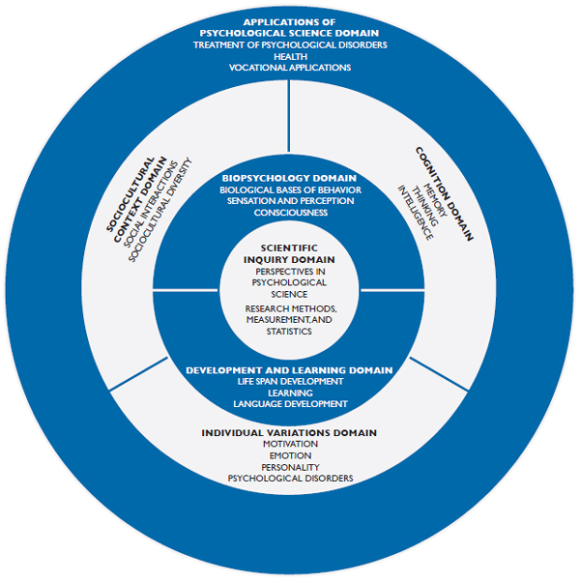

Grading

Criteria

All assignments are weighted equally, but will be given varying point value. Daily work will range between 5-25 points per assignment. Tests and Projects will range from 25- 100 points. Semester grade is determined by 50% third quarter and 50% fourth quarter. No semester test is required.

Late Assignments
Daily work and projects are created by teachers in order to see which concepts you fully understand and which areas you still need to review. If you do not understand an assignment, you need to see Mrs. Kokes before/after school, during study hall, or set up another time that works for your schedule. Late work will not be tolerated. If you fail to hand in an assignment you will attend 8th Period after school until the assignment is completed with quality. (Quality means 60% or more of the answers must be correct.) You will lose 25% of your original grade for any assignment turned in after the due date. If you do not understand the assignment, seek extra help or ask questions. Not handing in your assignment is NOT a wise option.
If you are absent, the district makeup policy will be followed. You will receive one school day for each day missed. For example, if you miss 3 days of school, you receive 3 days to make up the work. (See page 3 of the handbook.)
Grading Scale
Percentage GPA Points
A+ . . . 100 Superior 4.00
A . . . 95 - 99 Superior 4.00
A- . . . 93 - 94 Superior 3.67
B+ . . . 91 - 92 Above Average 3.33
B . . . 88 - 90 Above Average 3.00
B- . . . 86 - 87 Above Average 2.67
C+ . . . 83 - 85 Average 2.33
C . . . 78 - 82 Average 2.00
C- . . . 75 - 77 Average 1.67
D+ . . . 72 - 74 Passing, Below Average 1.33
D . . . 63 - 71 Passing, Below Average 1.00
D- . . . 60 - 62 Passing, Below Average 0.67
F . . . 59 & Below Failing 0.00

Course/District Policies
- Cheating – AVON SCHOOL DISTRICT 4-1 CHEATING POLICY (19)
  - Definition of cheating: Soliciting, acquiring, supplying or use of answers on
tests, quizzes, study guides or other assignments. Any type of plagiarism and/or copyright infringement on work turned-in is in violation of the cheating policy.
  - Punishment:
    - 1st Offense: Inform Parents; 1 day in-school suspension; Mandatory Semester
tests, 1 hour Saturday detention, "0" credit for the assignment.
    - 2nd Offense: Inform Parents; 2 day in-school suspension; mandatory semester tests throughout high school; 3 hour Saturday detention;
"0" credit for assignment; Not eligible for the honor roll for the remainder of the year.
    - 3rd Offense: Meeting with parents; 3 day out-of-school suspension; loss of credit for the class.
  - The classroom teacher will bear the responsibility to verify any and all cheating.
  - Only the classroom teacher and/or the secondary principal may impose the punishment.
- Cell Phones- See revised Avon School Policy 2012-13
- Food- Candy and gum chewing is allowed if it is done in a proper manner. HOWEVER, individual teachers may ask students not to eat candy or chew gum in their classrooms or study hall. There will be NO POP OR FOOD allowed in classrooms without prior approval from the administration (6).
- Classroom Disruptions/Behaviors- refer to the Disciple Grid on pages 6-7 in handbook.

Course Schedule (Tentative)
Week of
Jan 1 What is psychology? (Chapter 1)

Jan 7 What is psychology? (Chapter 1)

Jan 14 Psychology in Your Self- What shapes your personality? (Chapter 2)

Jan 21 What shapes your personality? (Chapter 2)

Jan 28 How do humans develop over time? (Chapter 3)
Midterm Thursday, January 31

Feb 4 How do humans develop over time? (Chapter 3)

Feb 11 Psychology in Your Body- How do neurons, hormones, and the brain shape behavior? (Chapter 4)

Feb 18 How do neurons, hormones, and the brain shape behavior? (Chapter 4)

Feb 25 What is consciousness? (Chapter 5)

March 4 What is the difference between sensation and perception? (Chapter 6)

End of the Third Quarter Thursday, March 7
March 11 Psychology in Your Mind - How do we think? (Chapter 7)

March 18 How do we think? (Chapter 7)

March 25 How do we utilize our memory? (Chapter 8)

April 1 Psychology in our Environment - How do we learn? (Chapter 9)
April 8 How does our culture/society shape our behaviors? (Chapter 10)
Midterm Friday, April 12
April 15 Your Mental Health- What are psychological disorders? (Chapter 11)
April 22 How do you treat a psychological disorders? (Chapter 12)

April 29 Your Life - How do emotions and stress impact your health? (Chapter 13)
May 6 What motivates you in life? (Chapter 14)

May 13 What careers are available in psychology?

Cited handbook pages can be accessed through the “Handbook” link on the Avon School Website or through the Avon School Main Office www.avon.k12.sd.us

